**COMPUTER NETWORKS QUIZ-03 (B) SOLUTION – BCS-5G**

* 1. First segment: seq= 494 , bytes= 499

second segment: seq= 993, bytes=499

third segment: seq= 1492, bytes 499

* 1. ACK for 2nd segment: 993

ACK for 3rd segment: 993

* 1. **UDP segment structure** 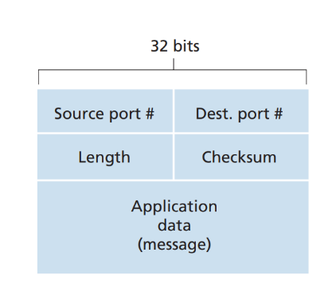
  2. **Size of UDP datagram:**

UDP Header + application layer header + message data

= 8 bytes + 700 bytes + 8 bytes

= 716 bytes

1. 
   1. **Sample 1:**

EstimatedRTT = (1-0.125)(200) + (0.125)(200) = 202.5

DevRTT = (1-0.25)(20) + 0.25(|220-200|) = 20

TimeoutInterval = 202.5 + 4(20) = 282.5

* 1. **Sample 2:**

EstimatedRTT = (1-0.125)(202.5) + (0.125)(210) = 203.44

DevRTT = (1-0.25)(20) + (0.25)(|210-202.5|) = 16.875

TimeoutInterval = 203.44 + 4(16.875) = 270.94

* 1. **Sample 3:**

EstimatedRTT = (1-0.125)(203.44) + (0.125)(240) = 208.01

DevRTT = (1-0.25)(16.875) + (0.25)(|240-203.44|) = 21.796

TimeoutInterval = 208.01 + 4(21.796) = 295.194

* 1. **Issue with Two-Way Handshake**:  
     **Old or Delayed Packets:** In a two-way handshake, there is no verification if the connection request is new or an outdated packet. A delayed packet could unintentionally trigger a connection, causing confusion.  
     **Synchronization Problem:** The two-way handshake does not confirm if both the client and server have successfully synchronized their sequence numbers, leading to possible data misalignment.
  2. **Solution with Three-Way Handshake**  
     **1.** **SYN (Synchronize):** The client sends a connection request (SYN) to the server with an initial sequence number.  
     **2.** **SYN-ACK (Acknowledge + Synchronize):** The server responds with a SYN-ACK, acknowledging the client’s SYN and sending its own initial sequence number.  
     **3. ACK (Acknowledge):** The client sends an ACK back to the server, confirming the server’s sequence number.  
     This three-step process ensures:  
     **Reliability:** Both the client and server confirm the connection request, reducing the risk of old or duplicate connection attempts.  
     **Synchronization:** Both the client and server synchronize their sequence numbers, ensuring data is properly aligned for transmission.